1. After Creating and logging into AWS account.

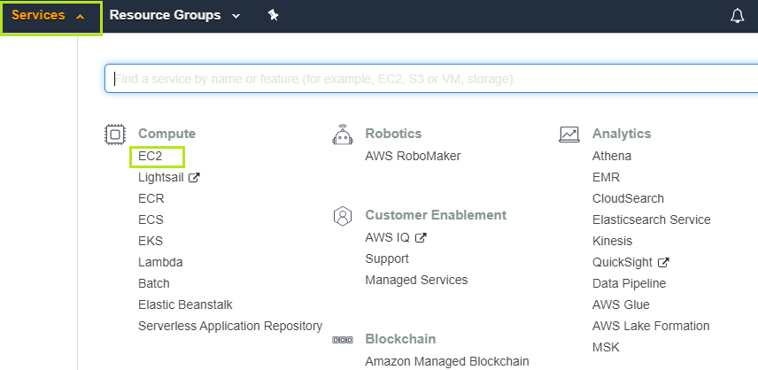

1. Choose EC2.

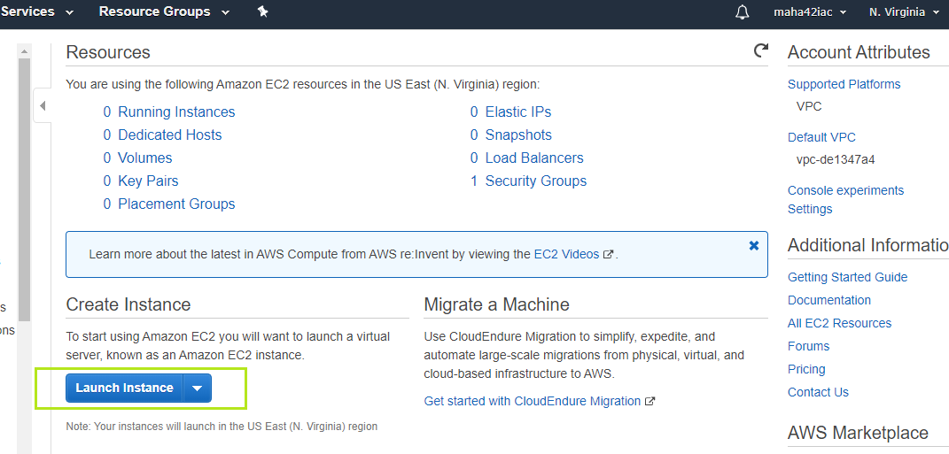

1. Click on Launch instance.

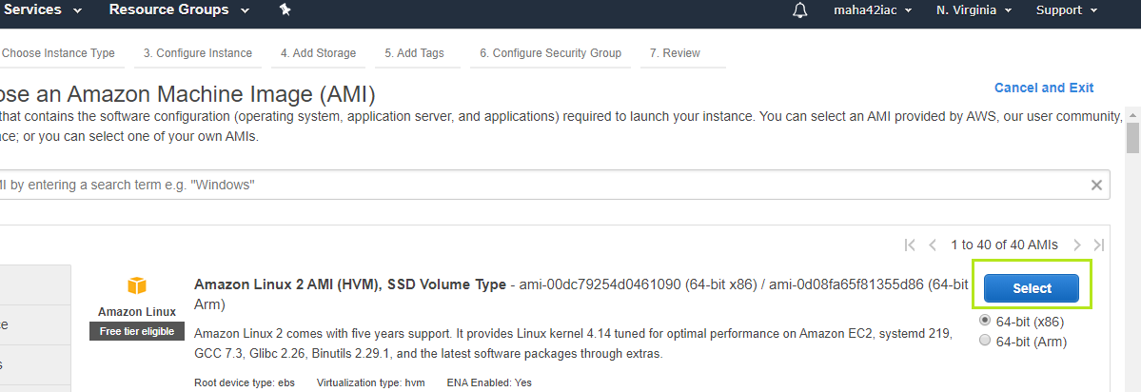

1. Choosing Amazon Linux AMI (OS) and click on select Button.

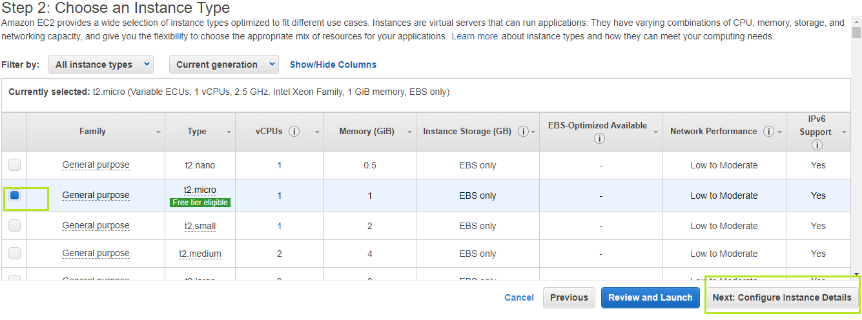

1. Choose t2.micro and click on configure instance details.

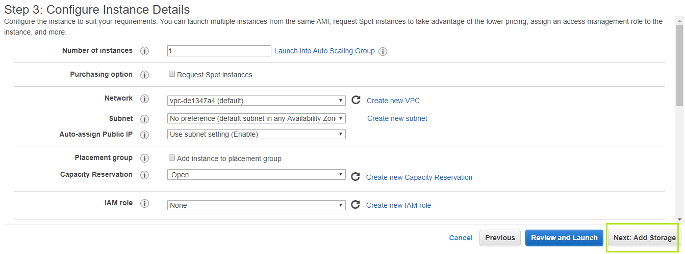

1. By choose default options and click on add storage.

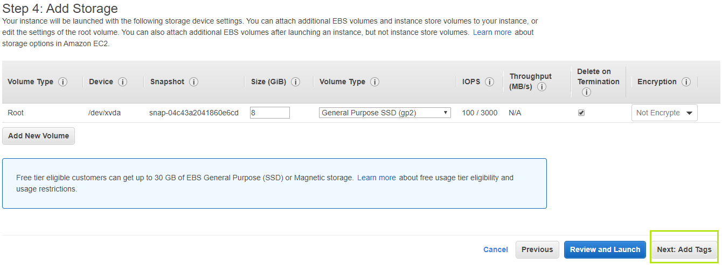

1. By choose default options and click on Add Tag.

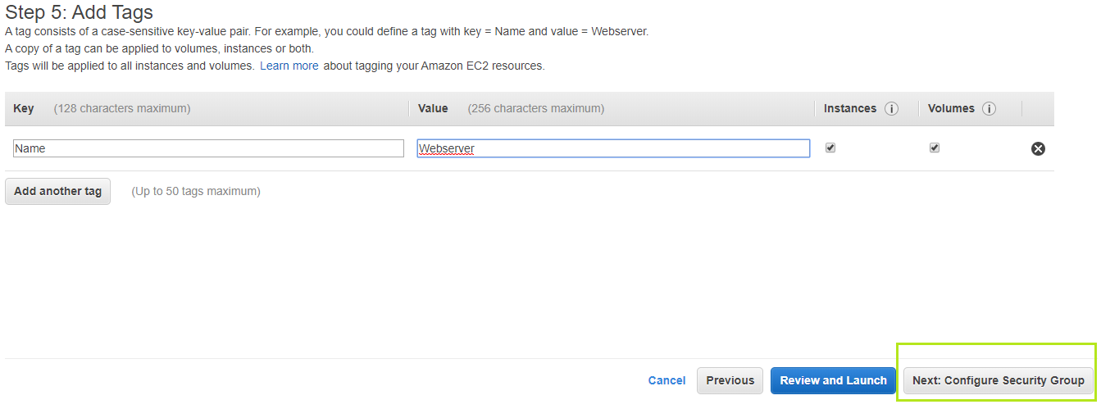

1. By give name of Instance (sever) and click on Configure security Group.

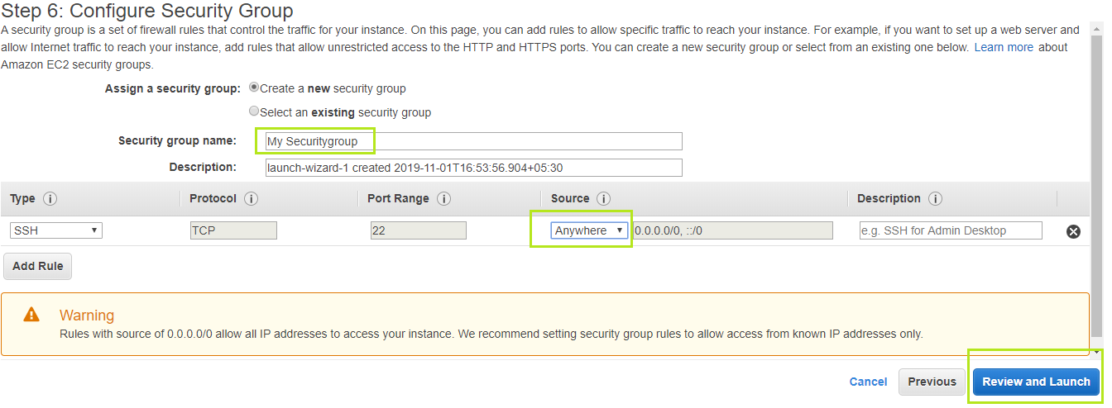

1. By give security group name , select anywhere and click on review and Lunch.

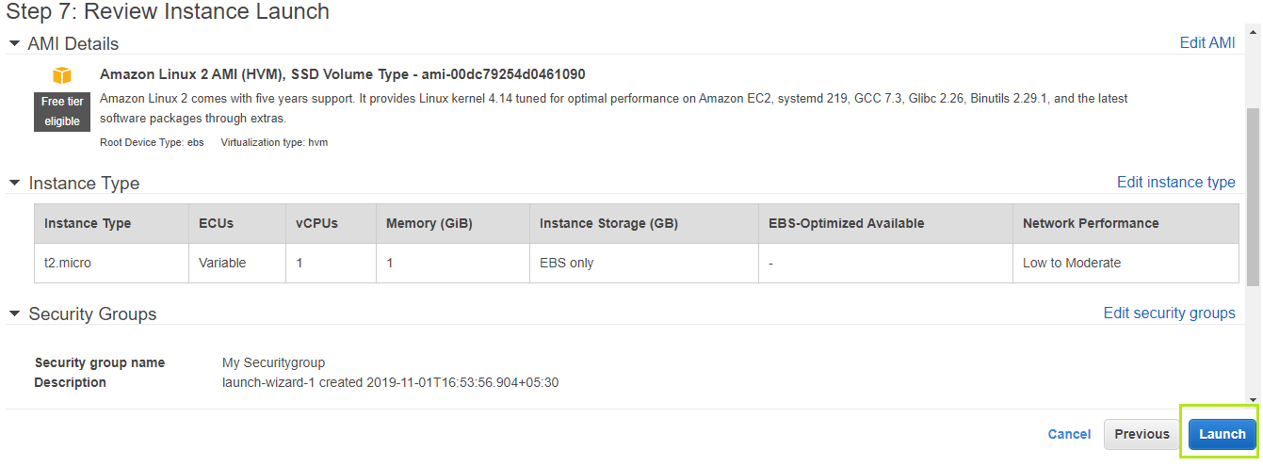

1. Click on Lanch.

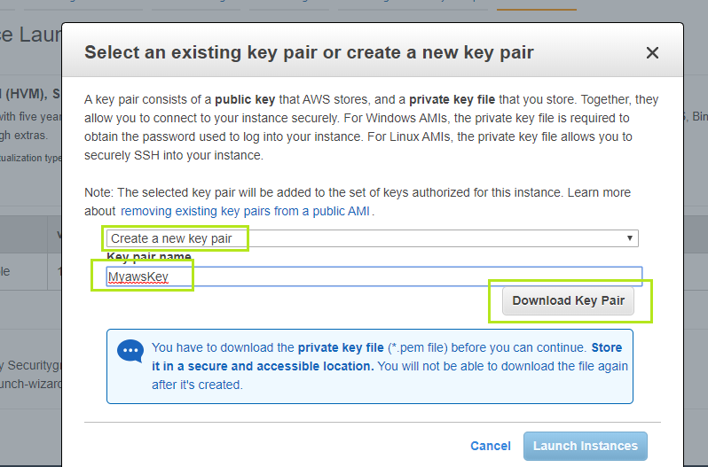

1. By choosing “create a new Key pair, give Key pair name any name ex: “ myawskey” and click on Download key pair.

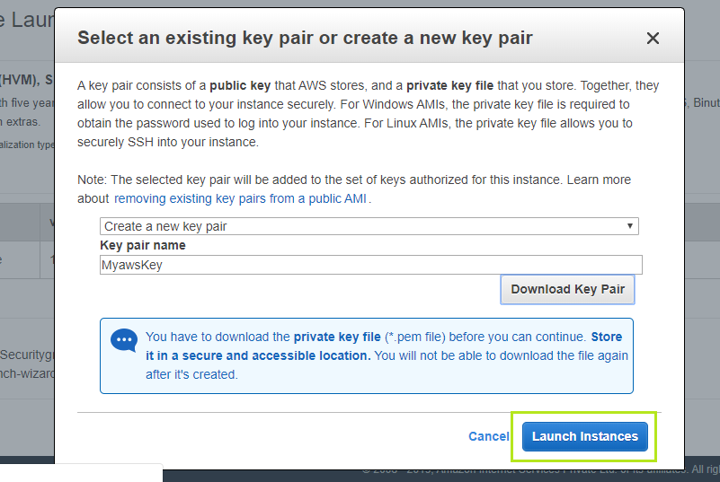

1. After download Key pair, we can click Launch Instance.
2. After launch click instance, in aws instance will be created

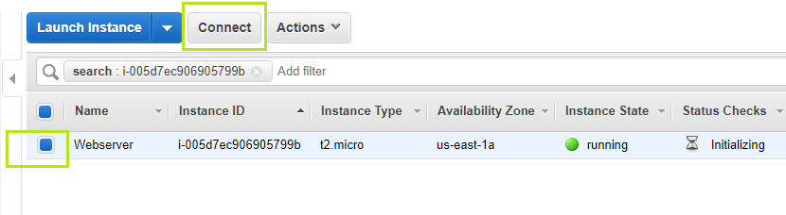

1. By choosing instance and click on connect.

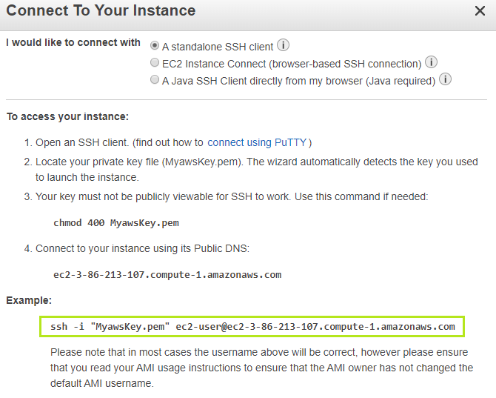

1. By copy above ssh connection link and past into git bash, we can able login aws amazon linux server.

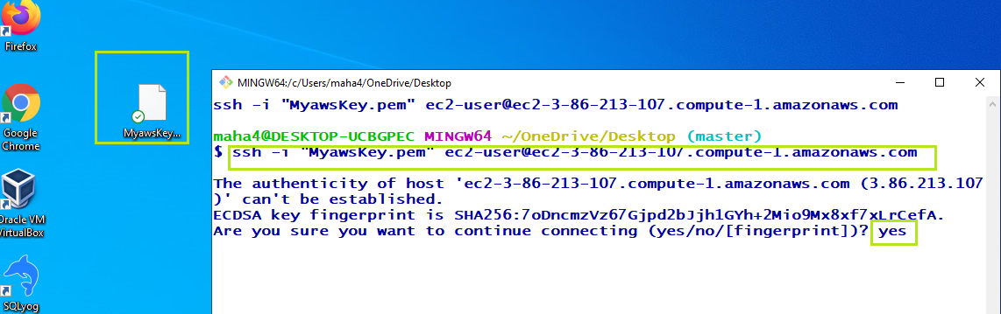

16 ) After install git on desktop, Right click, where you downloaded myawskey.pem ( key pair) and click gitbash option, then past your ssh connection link from aws account and type yes.

After successfully login into server, we can do any installations.